Agenda Chilmark Selectmen March 18th 2008 7:30 PM

Public Hearing – Inn At Blueberry Hill Niall Reid

Minutes March 3rd 2008

Triennial Reevaluation Sign Contracts for Personal Property and RE.
Green Shuttle of Cape Cod Jake Gifford

Police Update
Parking Tickets

Emergency Management

MLR UMASS Archeological Survey Phase II

Legal G&S, et al

Shellfish 2007 Report
Conference
Oyster Season
Quohog relay
Assistant Constable Supervision of propagation projects
Predator Control 18 weeks June 15 – Oct 30

John Pappalardo letter of support

CCC Waive rental for one flea market

Creek Lot Carl Flanders

Nabs Corner Housing Update on legislation
Timeline for survey and other actions

Dog Officer 10 chickens v. 2 dogs - bond

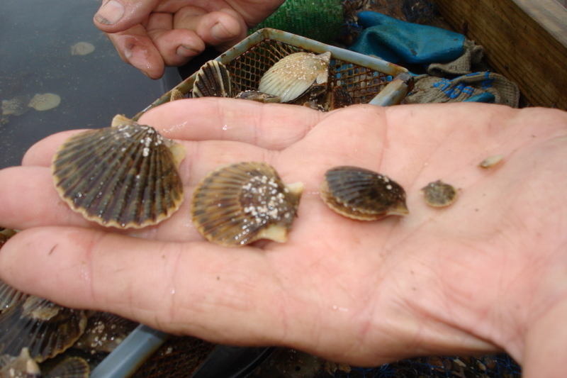
CALENDAR
March
19th Mr. Carroll out
19th Miss Orlando returns
20th Mr. Carroll out
20th Mr. Hodgkinson to workshop
26th Mr. Carroll out afternoon
27th Mr. Carroll In-Service, in late afternoon

